Northwest High School Athletics
Emergency Action Plan – Gym activities
(Volleyball, Basketball, and Wrestling)

Northwest School has a written emergency plan that should be followed in the event of a medical emergency. All coaches should be familiar with this document and their role and responsibility in an emergency. Any questions should be directed to the head athletic trainer (or school administrator, in the absence of a licensed athletic trainer).

An emergency is the need for Emergency Medical Services (EMS) to give further medical attention and/or transport an athlete to the hospital. It is important in these situations that coordination between the athletic trainer, coaches, administrators and student responders be effective. This guide is intended to delineate roles and outline the protocol to be followed should an emergency occur.

Situations when 911 should be called are:
- an athlete is not breathing
- an athlete has lost consciousness
- it is suspected that an athlete may have a neck or back injury
- an athlete has an open fracture (bone has punctured through the skin)
- severe heat exhaustion or suspected heat stroke
- severe bleeding that cannot be stopped

Chain of Command
Team Physician – Dr. Jason Jones, DO
Certified Athletic Trainer – Staci Hosley, MS, LAT, ATC
School Resource Officer
Athletic Director – Jessica Peppard
Administrator
Head Coach
Assistant Coach
Sports Medicine Student Assistant
Other Athletes

The highest person in the chain of command who is present at a scene will be the designated person in charge, or leader. That person is responsible for deciding whether or not to call 911, instructing others how they may be of help and will be the person who stays with the athlete until EMS arrives.

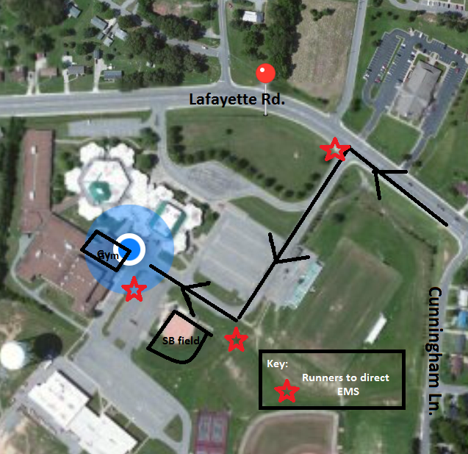

Northwest High School is located at:
800 Lafayette Rd
Clarksville, TN 37042

The closest intersection to the school is Lafayette and Cunningham Ln.
When approaching the school from Lafayette and Cunningham Ln., continue on Lafayette to the first left turn next to the football field. Follow through the parking lot until you approach the Softball field and make a right. Pull up to the front of the school. A student will be waiting at the front entrance to direct EMS to the gym.

Once it has been decided that EMS should be called, the following protocol should be followed:

EMERGENCY ACTION PLAN
1. Athletic Trainer and Team Physician (if present) will stay with the athlete to monitor the athlete’s condition and administer necessary first aid. If possible, someone else on the chain of command should also stay and assist. The front office or an administrator should be notified that there is an emergency situation on campus.

2. The highest person on the chain of command will make the call to EMS or will designate another person to make the call. (911 from a cell phone or pay phone) EMS should be told what the emergency is, the condition of the athlete and how to get to where the athlete is. Also, tell EMS that someone will meet them at the closest intersection to aid in directing the ambulance. DO NOT HANG UP UNTIL EMS HANGS UP FIRST.

3. Phones at Northwest High School are located in the main office, classrooms, coaches offices, and in the training room. All people listed on the chain of command will also have a cell phone on them in the event of an emergency.

4. The leader will send runners to all intersections between where the athlete is located: One runner to intersection of Lafayette and entrance of parking lot just past Cunningham Ln., One runner in front of Softball field to direct ambulance to front of school and a third runner at the entrance of the school to direct EMS to gym. The runners should stay in their positions and wave the ambulance through the proper turns to get to the athlete.

5. The athletic trainer will designate another person to attempt contact with the athlete’s parents. Emergency contact information can be found on physicals which coaches and athletic trainer, who should have with them at all times. If a parent is not present, the form should accompany the athlete to the hospital.

6. If transport is deemed necessary by EMS, the athlete will be taken to Gateway Medical Center, 651 Dunlop Ln, Clarksville, TN (931) 502-1000, unless the parent requests otherwise.

Location of AED’s
- Outside the gym across from coaches office, next to the 100 hallway.

*Coaches should take note of the closest AED to their practice and game locations.

IMPORTANT PHONE NUMBERS:

EMS: 911 or 9-911 from a school phone

Athletic Trainer: Staci Hosley, MS, LAT, ATC, CPT – (567) 868-9015

Athletic Director, Jessica Peppard – (931) 472-8043

Principal, Dr. Theresa Muckleroy – (931) 648-5675 ext. 2019

Main Office: (931) 648-5675

School Resource Officer, Deputy Michael W. Runyon-Davis – (931) 624-2499

